Calculus 1 Lecture 3.2: A BRIEF Discussion of Rolle's Theorem and Mean-Value Theorem.

Rolle’s Theorem:

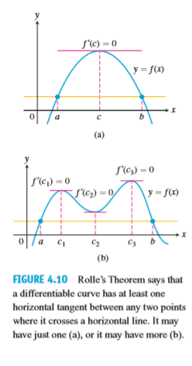

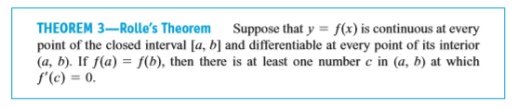

Mean Value Theorem:

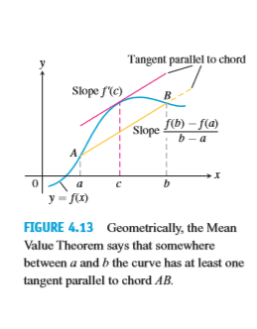

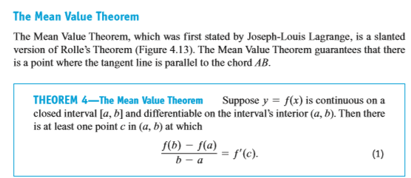

Example

